Tafadzwa Kashiri

ST10057559

CLVD6211 Part 2

Results

Query 5. Write a query that will return all the rentals placed between the following dates “2021-08- 01” AND “2021-10-30”.

Query 6. Write a query that selects all the rentals placed by Bud Barnes.

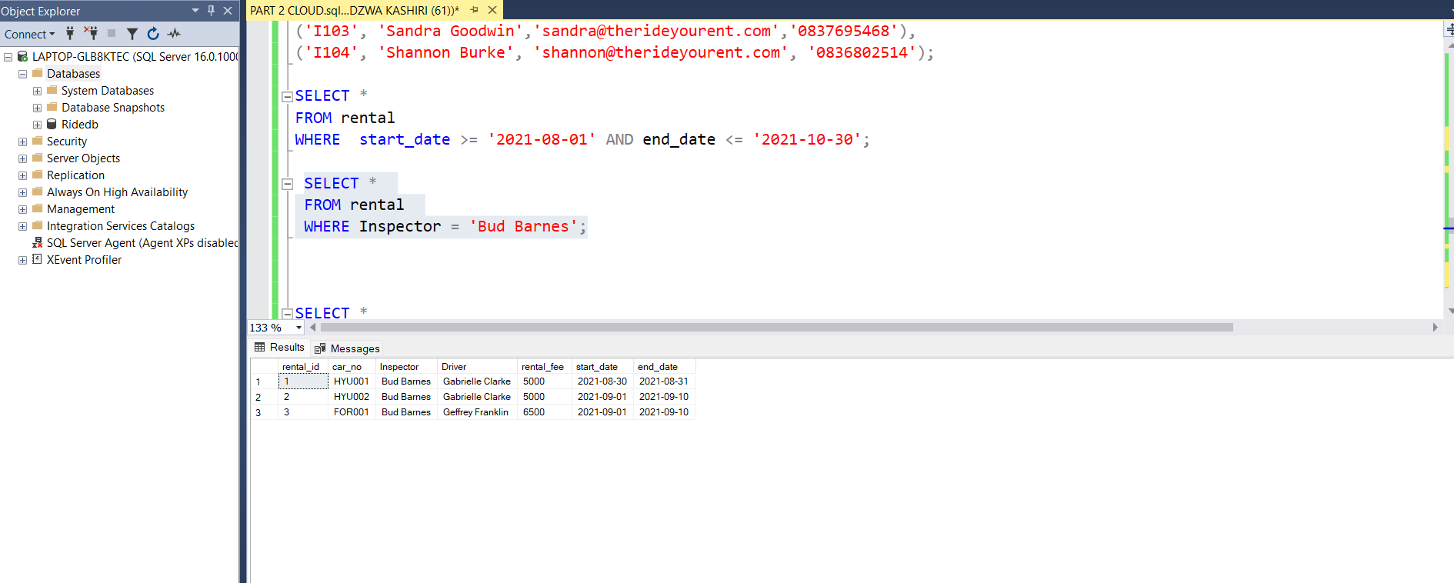

Query 7. Write a query that displays all the returns for the car make Toyota

Query 8. Write a query that counts the number of rentals that were placed for the car make Hyundai

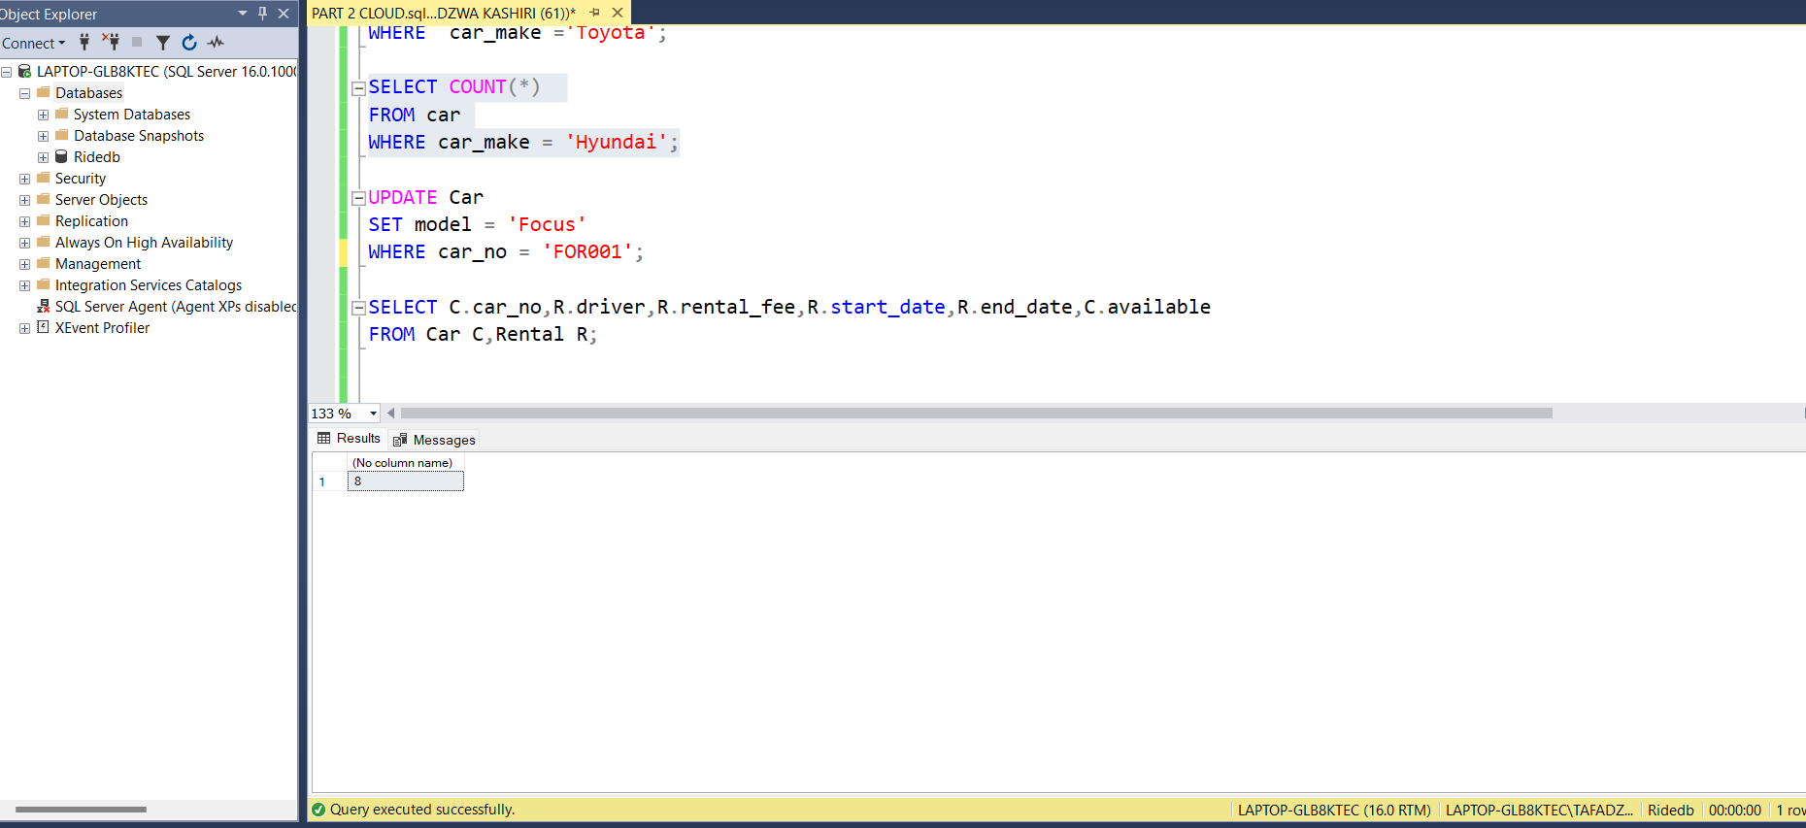

Query 9. Write a query to update the Model of the car with the CarNo FOR001 from “Fiesta” to “Focus”.

Query 10. Write a query that will display the CarNo, Driver Name, Rental Fee, Start Date, End Date and Availability of all available rentals

Query 12. Write a query that will determine the cars which will need service soon. If a car’s kilometres travelled is 9000 kilometres away from the service kilometres that would indicate that the car would need to get a service soon

Query 13. Write a query that will calculate the late fee for a return (a R500 a day fine is placed on rentals returned passed the elapsed return date. The query should use the return date and the current/Today’s date to calculate the elapsed number of days and multiply those days by the R500 fine to get the total fine)

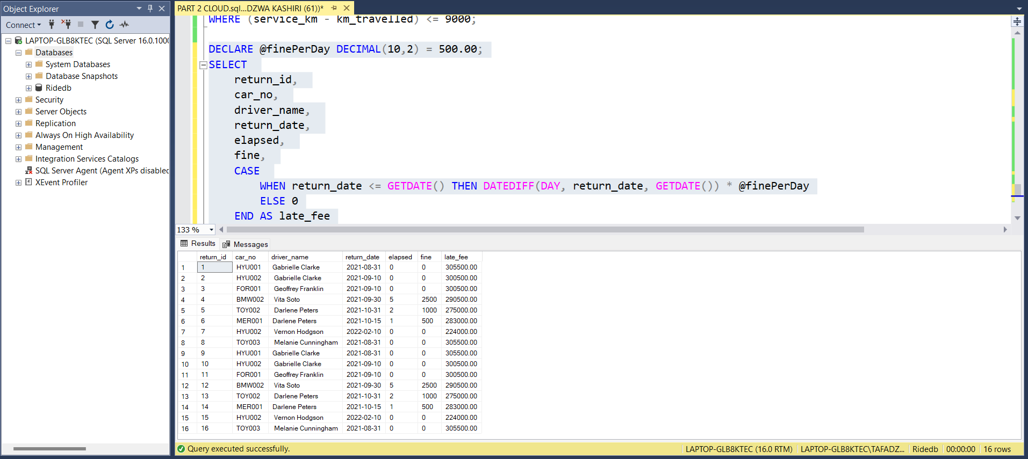

The connection to my MS Azure SQL Server (shown in my local SSMS) with at least one table result called back as a query.

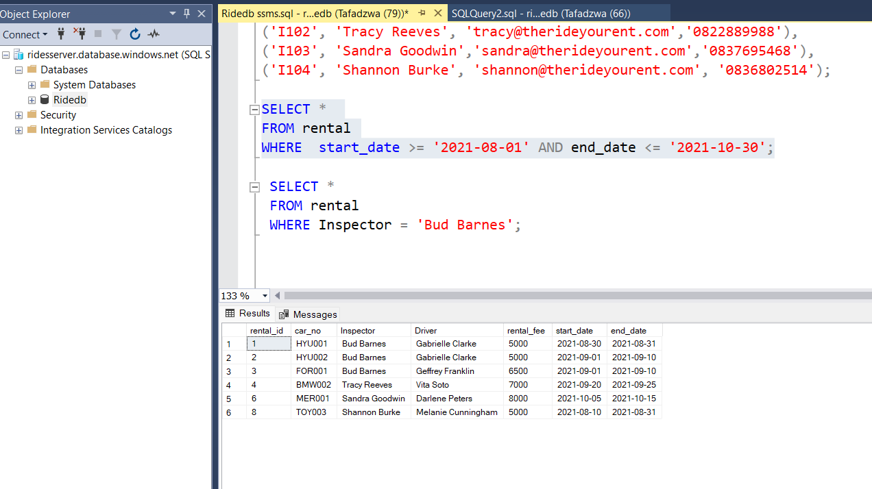

The data shows up in the query editor on Microsoft Azure

